1.Home Program creation, Report on TIC is enabled by default. On save Report on TIC is in disabled mode in the Program Grid.

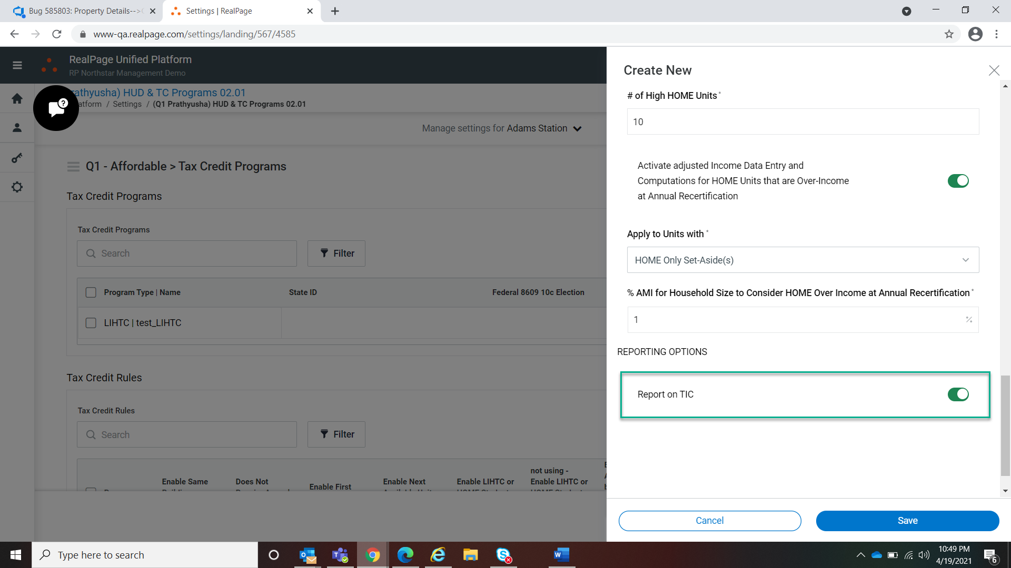

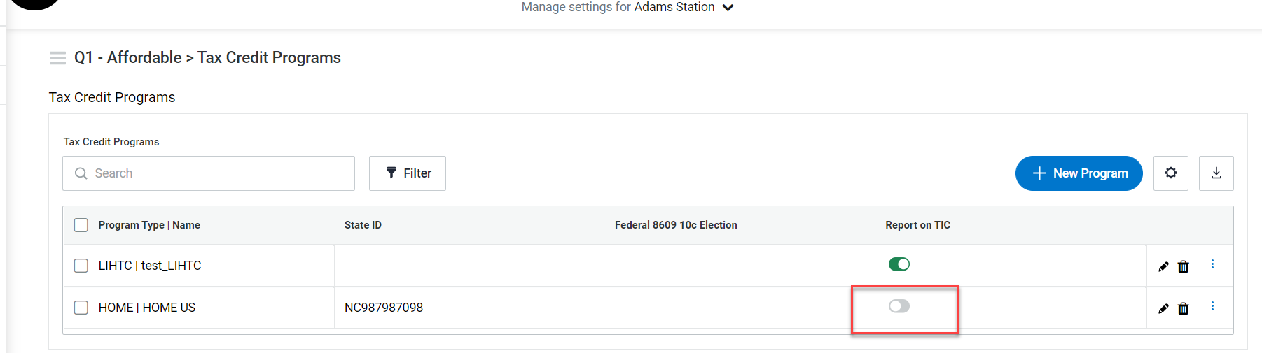

2.On Edit Program, Program Name ,Income Limit table & Enter Units Required by showing empty.

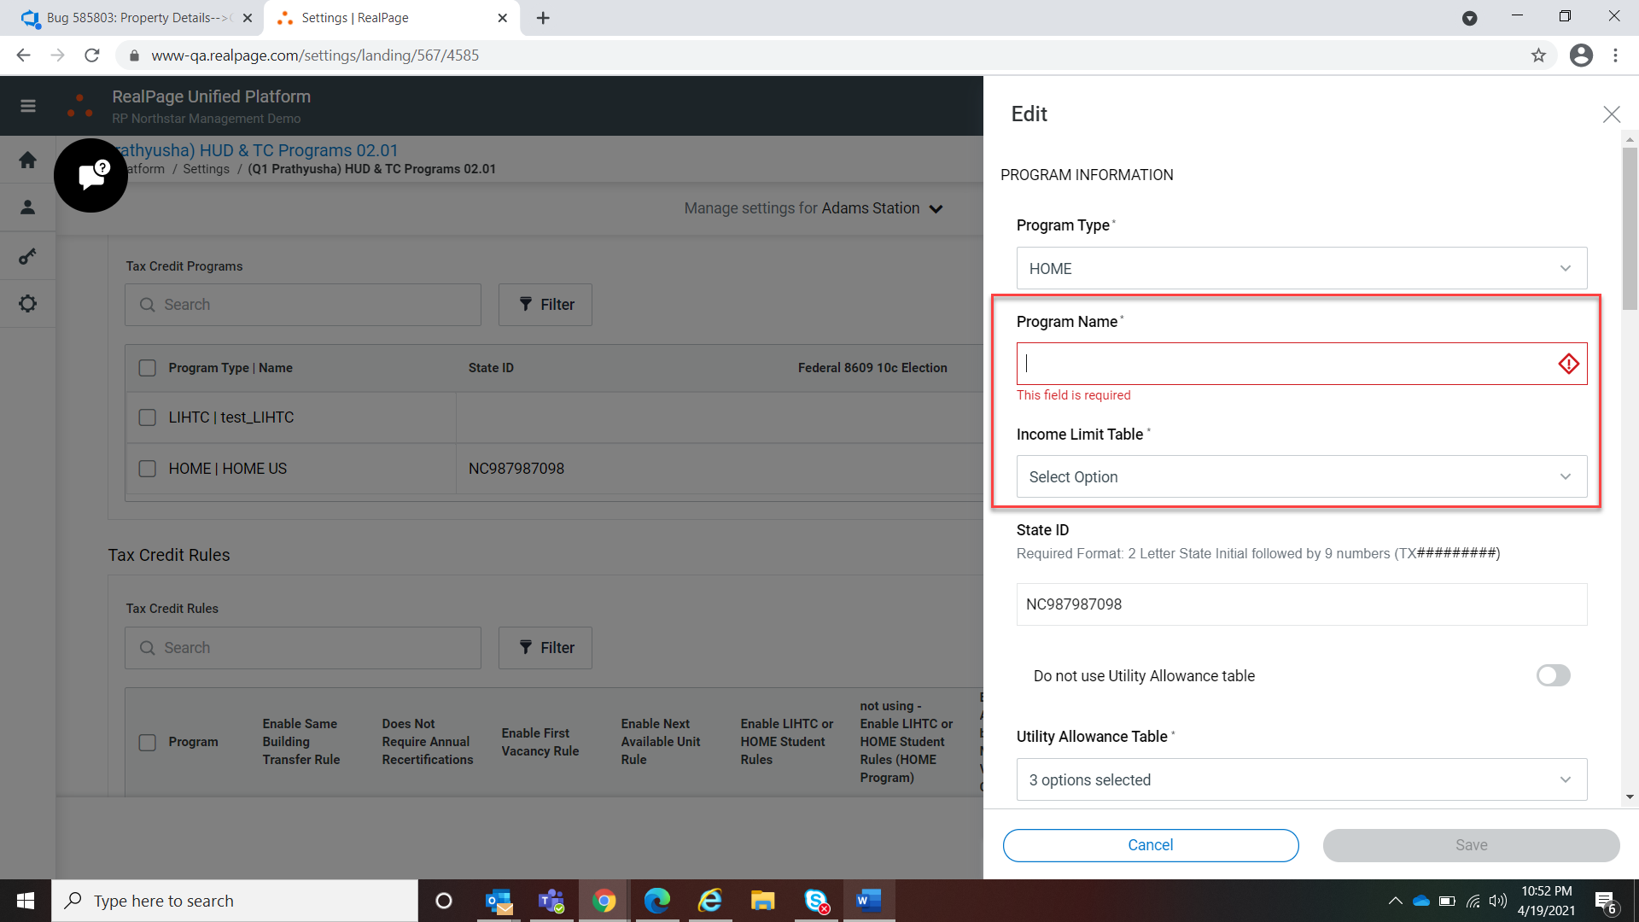

3.Rules, Number of BedRooms should be the default option instead of Square Footage for ‘First vacancy Rule Comparable Unit Definition’ drop down.

4.Rules,’Next Available Unit Rule Scope’ – Change the dropdown value to ‘Project Wide’ ,not ‘Property wide’.

5. Rules, By default toggle ‘Enable Rental Assistance to be Included in Maximum Rent Validation When Certifying’ should be ON and Open.

6.Assign Buildings to Program, By default ‘Include in Program’ toggle should be off.

7.While create the Program,Seleted ‘Floor Plan’ for “Enter Units Required by” field But on save the data is getting saved for Bed room grid instead of Floor Plan.

